7th Grade Common Assessment #1

- The table below shows the distance Hernando rode on each day of a five-day cycling trip.

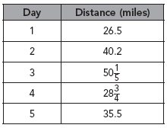

What was the total distance Hernando cycled on his trip?

A 78.95 mi
B 102.2 mi
C 181.15 mi
D 192.5 mi

- What is 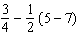 in simplest form?

A
B
C
D

- Which expression has the greatest value?

A 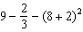
B 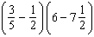
C 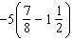
D 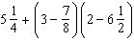

- Kavita recorded the mass of each mineral sample, and the mass of all the samples together. Water splashed on her notebook and smudged how much the third mineral sample weighed. How much did that sample weigh?

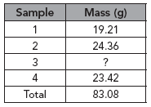

A 16.09 g
B 17.09 g
C 66.99 g
D 150.07 g

- What is equal to 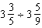?

A
B
C
D

- Javon is dividing 2.5 pounds of almonds equally among 3 friends and himself. How many pounds of almonds will each person get?

A 0.625 lb
B 0.83 lb
C 7.5 lb
D 10 lb

- What is the simplest form of the expression 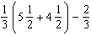?

A
B 4
C
D

- Karla says that the value of the expression is 35. Su Li says that the value of the expression is 17. Which choice best describes who is right and why?

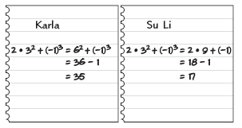

A Karla is right because she used the correct order of operations.
B Karla is right because she subtracted 1 from 36.
C Su Li is right because she used the correct order of operations.
D Su Li got the right answer, but her work is wrong because she did not find (–1)³.
- Mark buys 2 sweatshirts and a book costing $5.98 for a total of $38.92 before tax. Which equation can be solved to find the price of one sweatshirt?

A 2s – 5.98 = 38.92
B 2s + 5.98 = 38.92
C 5.98s + 2 = 38.92
D 5.98s – 2 = 38.92

- Jaron is buying an MP3 player for $62 and some DVDs for $8 each. He spends a total of $118 before tax. Which equation models this situation?

A 62x + 8 = 118
B 62x – 8 = 118
C 62 + 8x = 118
D 62 – 8x = 118

Demonstrate your knowledge by giving a clear, concise solution to each problem. Be sure to include all relevant drawings and justify your answers. You may show your solution in more than one way or investigate beyond the requirements of the problem.

Jennifer is shopping for food for her party.

a. She bought pounds of bologna and pounds of turkey breast. How much more turkey breast than bologna did she buy? Find the answer using two different methods. Explain how you found your answers.

b. If a recipe for punch calls for gallon of fruit drink, how much fruit drink will Jennifer need to make batches of the recipe? Explain how you found your answers.

7th Grade Common Assessment #1
Answer Key

Question Number | Answer | Skill Number
1 | C | 0706.2.1 – Simplify numerical expressions involving rational numbers.
2 | D | 0706.2.1 – Simplify numerical expressions involving rational numbers.
3 | C | 0706.2.1 – Simplify numerical expressions involving rational numbers.
4 | A | 0706.2.1 – Simplify numerical expressions involving rational numbers.
5 | B | 0706.2.1 – Simplify numerical expressions involving rational numbers.
6 | A | 0706.2.1 – Simplify numerical expressions involving rational numbers.
7 | D | 0706.2.1 – Simplify numerical expressions involving rational numbers.
8 | C | 0706.2.1 – Simplify numerical expressions involving rational numbers.
9 | B | 0706.3.7 – Translate between verbal and symbolic representations of real-world phenomena involving linear equations.
10 | C | 0706.3.7 – Translate between verbal and symbolic representations of real-world phenomena involving linear equations.
** Multiple Choice questions are worth 8 points each.

Constructed Response

a. Method 1: 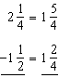
Method 2:
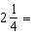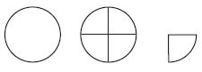
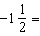
_______ _____________________________
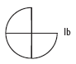

b. 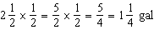

Constructed Response Rubric
Score | Expectations
Full Credit (20 points) | - Your response addresses all parts of the question clearly and correctly.  - You use and label the proper math terms in your answer.  - Your response shows all the steps you took to solve the problem.
Partial Credit (15 points) | - Your response addresses most parts of the question correctly.  - Your response does not show all of your work or does not completely explain the steps you took to solve the problem.
Minimal Credit (10 points) | - Your response addresses only one part of the question correctly and explains the steps you took to solve that one part. In answering the remaining parts of the question, your response is incomplete or incorrect.  - Your response does not show all of your work or does not explain all of the steps you took to solve the problem
No Credit (0 points) | - Your response is incorrect.
**The constructed response question is worth up to 20 points

