8th Grade Common Assessment #1

- The table below outlines the cost of a monthly gym membership.

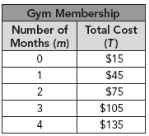

Which equation best represents this relationship?

A T = 45m
B T = 30m
C T = 30m + 15
D T = 15m
- Which equation describes the relationship between the corresponding values of x and y shown in the table?

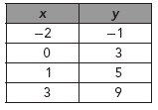

A y = x + 1
B y = 2x – 3
C y = 2x + 3
D y = 3x + 5
- What is the slope of the line that contains points (7, 8) and (15, 30)?

A
B
C
D

- What is the slope of the line shown?

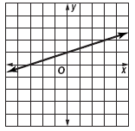

A 3
B 2
C
D
- What is the slope of the line shown?

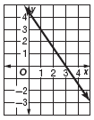

A
B
C
D
- What is the slope of the line containing (–4, 2) and (0, –10)?

A –7
B –3
C
D 3

- Which of the following ordered pairs is a solution of the equation represented by the line shown on the graph?

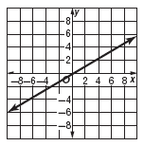

A (4, 7)
B (7, 4)
C (6, –2)
D (–2, 6)
- Which of the following ordered pairs is a solution for the linear function represented on the graph?

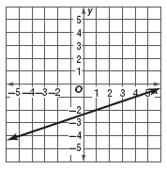

A (–5, 0)
B (–2, –3)
C (3, 1)
D (6, 0)

- Which of the following graphs shows a nonlinear function?

A 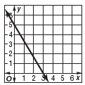
B 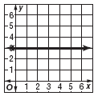
C 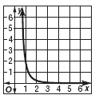
D 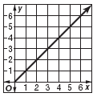

- The graphs below represent the price of an item over a 7-day period. Which graph is not linear?

A 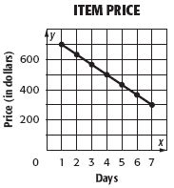
B 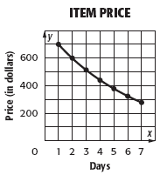
C 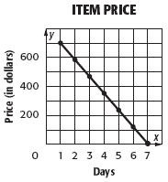
D 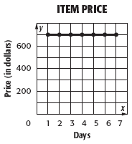

Demonstrate your knowledge by giving a clear, concise solution to each problem. Be sure to include all relevant drawings and justify your answers. You may show your solution in more than one way or investigate beyond the requirements of the problem.

Consider the function y = 2x – 3

a. Complete the following function table.

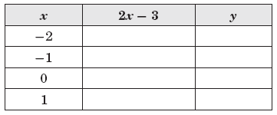

b. Is the function linear or nonlinear? How can you determine this using the table?

c. Graph the function. Connect the points and describe the graph.

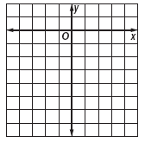
8th Grade Common Assessment #1
Answer Key

Question Number | Answer | Skill Number
1 | C | 0806.3.4 – Translate between various representations of a linear function.
2 | C | 0806.3.4 – Translate between various representations of a linear function.
3 | A | 0806.3.4 – Translate between various representations of a linear function.
4 | C | 0806.3.4 – Translate between various representations of a linear function.
5 | A | 0806.3.4 – Translate between various representations of a linear function.
6 | B | 0806.3.4 – Translate between various representations of a linear function.
7 | B | 0806.3.6 – Analyze the graph of a linear function to find solutions and intercepts.
8 | B | 0806.3.6 – Analyze the graph of a linear function to find solutions and intercepts.
9 | C | 0806.3.7 – Identify, compare and contrast functions as linear or nonlinear.
10 | B | 0806.3.7 – Identify, compare and contrast functions as linear or nonlinear.
** Multiple Choice questions are worth 8 points each.

Constructed Response

a. 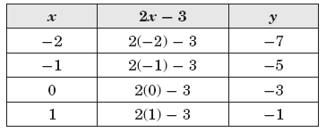

b. Linear; as the x values go up by 1, the y values go up by 2 each time. Since the rate of change is constant, the function is linear.

c. The graph is a straight line.

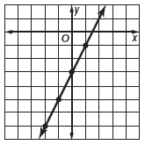
Constructed Response Rubric
Score | Expectations
Full Credit (20 points) | - Your response addresses all parts of the question clearly and correctly.  - You use and label the proper math terms in your answer.  - Your response shows all the steps you took to solve the problem.
Partial Credit (15 points) | - Your response addresses most parts of the question correctly.  - Your response does not show all of your work or does not completely explain the steps you took to solve the problem.
Minimal Credit (10 points) | - Your response addresses only one part of the question correctly and explains the steps you took to solve that one part. In answering the remaining parts of the question, your response is incomplete or incorrect.  - Your response does not show all of your work or does not explain all of the steps you took to solve the problem
No Credit (0 points) | - Your response is incorrect.
**The constructed response question is worth up to 20 points

