TCAP Blitz Assessment – 7th Grade
Week 5

- A person is casting a shadow next to the James K. Polk State Office Building’s shadow. The lengths of the shadows are shown below. What is the height of the James K. Polk State Office Building?

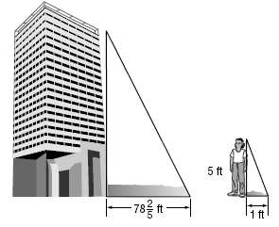

A | 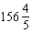 ft
B | 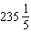 ft
C | 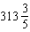 ft
D | 392 ft

- A model of the Eiffel Tower in Paris, Tennessee, casts a shadow at the same time as a person who is 5 feet tall, as shown below. How tall is the model?

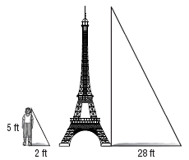

A | 280 ft
B | 210 ft
C | 140 ft
D | 70 ft

- The state tree of Tennessee is a tulip poplar tree. Einat measured the length of the shadow of a yardstick and the shadow of the tulip poplar tree. How tall is the tree?

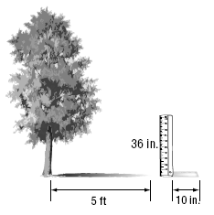

A | 30 ft
B | 18 ft
C | 12 ft
D | 10 ft

- Mr. Smith sells two sizes of children’s sandboxes. The base of the smaller sandbox measures 72 inches by 55 inches as shown below.

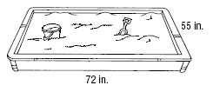

If the larger sandbox is twice the length and width of the smaller sandbox, what is the area of the base of the larger sandbox?

A | 3,960 in²
B | 7,920 in²
C | 11,880 in²
D | 15,840 in²

- In the figure below, a small cone is wedged into the top of a large cone.

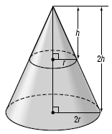

The radius of the large cone is twice the radius of the small cone. The height of the large cone is twice the height of the small cone. Which statement best describes the volume of the large cone?

A | 2 times the volume of the small cone
B | 3 times the volume of the small cone
C | 6 times the volume of the small cone
D | 8 times the volume of the small cone

- A veterinarian weighs piglets in a litter. The weights in pounds are listed below.

0.8, 0.9, 0.6, 0.8, 0.7, 0.5, 0.9

What is the third quartile of the data?

A | 0.55
B | 0.65
C | 0.85
D | 0.90

- Use the line plot below. What is the mean number of books read?

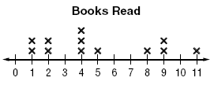

A | 5 books
B | 5.2 books
C | 5.5 books
D | 6 books

- What is the median height of the seventh graders whose heights are recorded in the stem-and-leaf plot?

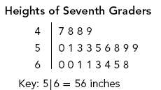

A | 50 in
B | 53 in
C | 56 in
D | 59 in

- Brent rolls a number cube labeled from 1 to 6 and tosses a penny at the same time. What is the probability that he will roll an even number and toss heads?

A | 0.25
B | 0.33
C | 0.5
D | 0.66

- A family is trying to decide among the ten campsites available for car camping in the Great Smoky Mountains. They write each name on a piece of paper, then choose one at random out of a hat. What is the probability that they choose Cataloochee or Cades Cove?

A
B
C
D

