TCAP Blitz Assessment – 6th Grade
Week 5

- A survey found that 7 out of 10 homes in the city of Hometown have a computer. If there are 14,000 homes in Hometown, how many homes could be predicted to have computers?

A | 7
B | 4,000
C | 9,800
D | 20,000

- The table below shows the output of a pump at a milk processing plant.

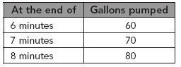

At this rate, what is the prediction for how many gallons of milk will be pumped at the end of 13 minutes?

A | 110 gal
B | 120 gal
C | 130 gal
D | 140 gal

- Four avocados cost $4.69. With $1.25, Valeria estimates she has enough to buy one avocado. Which statement best describes her estimate?

A | Her estimate is too high.
B | Her estimate is too low.
C | Her estimate is reasonable.
D | She can buy 2 avocados.

- Paulina logged her work for this week in the table below.

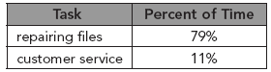

She estimates that she spent about 10% of the rest of her time doing other miscellaneous work. Which is a true statement about Paulina’s estimate?

A | The estimate is too low.
B | The estimate is too high.
C | The estimate is reasonable.
D | More information is needed to judge the accuracy of the estimate.

- The high temperature on Monday was 83°F. On Tuesday, the high temperature was 87°F. Which integer represents the high temperature on Monday?

A | –4
B | 4
C | 83
D | 87

- Which integer best represents the temperature shown on the thermometer below?

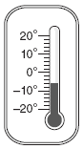

A | 6
B | 4
C | –4
D | –6

- Which sentence best shows how the distributive property could be used to find the product of 8 and 5.6?

A | 8 × (5 + 0.6) = (8 × 5) + 0.6
B | 8 × (5 + 0.6) = (8 × 5) (8 + 0.6)
C | 8 × (5 + 0.6) = (8 × 5) + (8 × 0.6)
D | 8 × (5 + 0.6) = (8 + 5) (8 + 0.6)

- Which property does the sentence below represent?

18 + (23 + 19) = (18 + 23) + 19

A | distributive property
B | commutative property of addition
C | associative property of addition
D | commutative property of multiplication

- Look at the key.

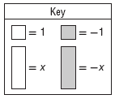

Which expression best represents the model below?

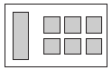

A | 6x + 1
B | –6x + (–1)
C | 1x + 6
D | –1x + (–6)

- Look at the key.

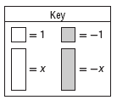

Which expression best represents the model below?

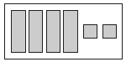

A | –4x + (–2)
B | –2x + (–4)
C | 4x + 2
D | 2x + 4

