TCAP Blitz Assessment – 6th Grade
Weeks 1 – 2

- Paola has pound of pepitas. She wants to store them in smaller bags that each hold pound. How many bags will she need?

A
B
C
D 4

- A box of steaks weighs 6 pounds. Each steak in the box weighs pound. How many steaks are in the box?

A steaks
B 6 steaks
C steaks
D 16 steaks
- Darius used 11 scoops of flour in a recipe. Each scoop was cup. How many cups of flour did he use?

A cups
B 4 cups
C cups
D 11 cups

- Cecilia kept a log of her activities one day. The table below shows Cecilia’s activities and the amount of time she spent on each activity.

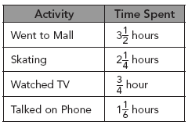

What was the total amount of time Cecilia spent on all of her activities?

A hrs
B hrs
C hrs
D hrs
- According to Tennessee state records, the heaviest largemouth black bass caught weighed pounds. The largest spotted black bass caught weighed pounds. What is the difference in the weights of the two fish?

A pounds
B pounds
C pounds
D pounds

- The length of a patio is times its width. The width of the patio is feet. What is the length of the patio?

A 30 ft
B 31 ft
C ft
D ft

- How much will Emilio pay to buy 3.8 pounds of cabbage shown below?

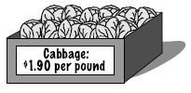

A $3.46
B $3.80
C $4.14
D $7.22

- Tina’s mom is buying snacks for their weeklong camping trip. The special trail mix at Fresh Market costs $3.40 per pound. How much will it cost to buy 6.75 pounds?

A $22.34
B $22.95
C $28.25
D $29.03

- The average high temperature in Tennessee is 91.5° and the average low is 27.8°. What is the difference in the temperatures?

A 63.7°
B 71.3°
C 73.7°
D 74.7°

- Maurice has 10 yards of material. He cuts off two pieces. One piece is yards long and the other piece is yards long. What is the length of the material Maurice has left?

A yd
B yd
C yd
D yd

- Diego and two friends mow lawns to earn money. They agree to split the cost of buying 4 gallons of gas that sells for $2.49 a gallon. How much will each person’s share be to the nearest cent?

A $1.87
B $2.49
C $3.32
D $4.98
- Ms. Jackson wrote the number on the board. Which of the following is equivalent to ?

A
B 0.411
C 1.14
D 2.75

- The forested land area of Tennessee covers 51.6% of the state. What improper fraction is equivalent to 51.6?

A
B
C
D

- The ratio of teachers to students at Elk Run School is 4 to 108. If there are 540 students at the school, how many teachers are there?

A 15
B 17
C 19
D 20
- Aaliyah bought a dress on sale. The dress regularly sold for $70. She saved 28% by buying the dress on sale. How much did she save?

A $1.96
B $19.60
C $20
D $28

- Melanie has 80% of the questions on her math test correct. There are 25 questions on the test. How many questions does she have correct?

A 15
B 18
C 20
D 21

- Which graph correctly shows the location of 0.7, , , and 20% on a number line?

A 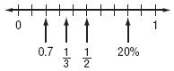
B 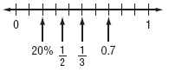
C 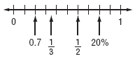
D 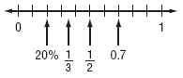

- Which graph best shows the location of point M at

A 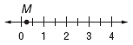
B 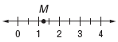
C 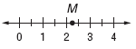
D 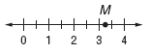

- The temperature at noon was 48° above zero. Which graph best shows the location of the temperature at noon on the number line?

A 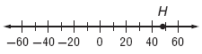
B 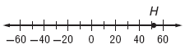
C 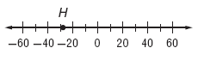
D 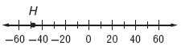

- The Jaguars basketball team led their opponent by 13 points at halftime. Which graph best shows Point B at 13?

A 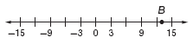
B 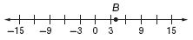
C 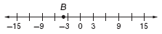
D 