TCAP Blitz Assessment – 6th Grade
Week 6

- What is the measure of angle C in the triangle below?

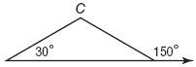

A | 30°
B | 60°
C | 90°
D | 120°

- What is the measure of angle A in the figure below?

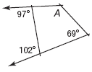

A | 78°
B | 83°
C | 130°
D | 230°

- Look at the drawing of the circular state seal.

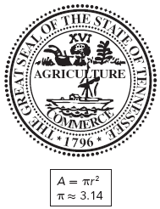

What is the area of the state seal if its diameter is about 2 inches?

A | 3.14 in²
B | 6.28 in²
C | 31.4 in²
D | 62.8 in²

- The figure below is Tennessee’s state seal.

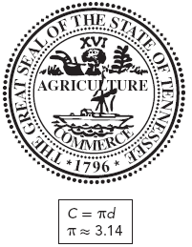

What is the circumference of the seal if its diameter is about 2.25 inches?

A | about 3.14 in.
B | about 3.45 in.
C | about 3.53 in.
D | about 7.07 in.

- Help Jennifer find the missing dimensions of the prism below. What is the value of x?

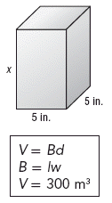

A | 10 inches
B | 12 inches
C | 55 inches
D | 300 inches

- All of the faces of the triangular pyramid below are equilateral triangles each with a height of 3.5 feet and a base of 4 feet.

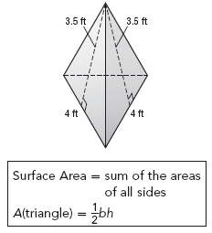

What is the surface area of the triangular pyramid?

A | 7 ft²
B | 14 ft²
C | 21 ft²
D | 28 ft²

- The graph below shows the number of pastries sold in the summer at a bakery. What about the graph is misleading?

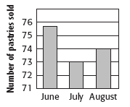

A | The bars should be horizontal.
B | The scale on the vertical axis is not accurate.
C | The scale on the horizontal axis is not accurate.
D | There is a break in the vertical axis.

- Sara made this bar graph to show how many laps she and three other girls swam.

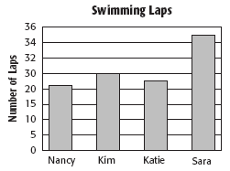

What feature of the graph is misleading, making it seem as if Sara swam many more laps than the other girls did?

A | There is a break in the horizontal axis.
B | The vertical scale is inconsistent.
C | The increments are too large.
D | The increments are too small.

- Leslie surveyed people entering a park on two different weekends. She asked those who had dogs with them whether they were in favor of building a dog park. Which best explains why her survey may be biased?

A | She only asked people with dogs.
B | She asked too many people.
C | She only asked children.
D | She surveyed on more than one day.

- Four students want to survey their school about an upcoming bake sale. Listed below are their plans for conducting the survey.

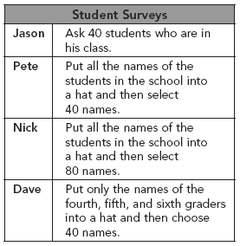

Which of the students’ methods would be best to get a sample that is not biased?

A | Jason
B | Pete
C | Nick
D | Dave

