TCAP Blitz Assessment – 7th Grade
Week 3

- What is the simplest form of the value of the expression 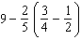?

A
B
C
D

- What is the simplest form of the expression 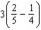?

A
B
C
D

- Which of the following symbols, when placed in the blank, will make the number sentence true?

A | <
B | >
C | =
D | +

- Which number is greatest?

A
B
C
D

- A scuba diver dives 37 feet below the surface. Then the diver rises 4 feet per minute. Which integer describes the position of the diver in relation to the surface of the water 5 minutes after beginning to rise?

A | –39
B | –38
C | –17
D | –7

- A scuba diver dives 45 feet below the surface. Then the diver rises 3 feet per minute. Which integer describes the position of the diver in relation to the surface of the water 6 minutes after beginning to rise?

A | –42
B | –39
C | –37
D | –27

- Of the 95 counties in Tennessee, 41 are in Middle Tennessee. About what percent of counties in Tennessee are not in Middle Tennessee?

A | 37%
B | 43%
C | 48%
D | 57%

- Which ratio is equivalent to 60%?

A
B
C
D

- In a bag of blue and red markers, the ratio of blue markers to red markers is 2:7. If the bag contains 90 markers, how many blue markers are there?

A | 11
B | 14.5
C | 20
D | 25.7

- Lupe wants to know which size of her favorite cereal is the most economical.

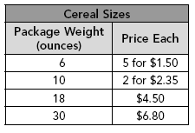

Which size package, and how many, should Lupe buy?

A | five 6-ounce packages
B | two 10-ounce packages
C | one 18-ounce package
D | one 30-ounce package

