TCAP Blitz Assessment – 6th Grade
Weeks 1 – 2

- What is the value of the expression when 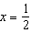?

A
B
C
D

- What is the value of the expression 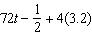 when ?

A | 12
B | 77.8
C | 146
D | 300.3

- The graph below shows the cost of admission to the Children’s Museum of Memphis. What is the slope of the graph? What does the slope mean?

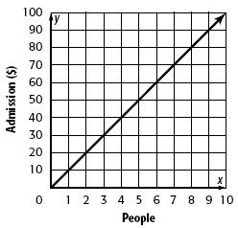

A | 10; admission is $10 for 1 person.
B | 10; admission is $1 for 10 people.
C | 5; admission is $5 for 1 person.
D | 1; admission is $1 for 1 person.

- Crocodiles can move quickly on land for short periods of time. Typically crocodiles can reach speeds of 12 to 14 kilometers per hour. The graph shows the relationship between time and the distance that a crocodile can move.

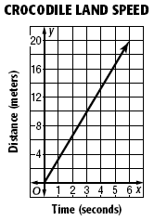

On the graph, what represents the speed of a crocodile?

A | the y-intercept
B | the x-intercept
C | the x-intercept
D | the length of the line

- Race cars at the Daytona 500 often exceed 2.5 miles per minute. What does the slope of the line represent?

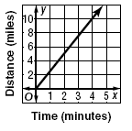

A | total distance
B | maximum speed
C | starting time
D | speed

- Which equation shows a proportional relationship?

A | y = x + 4
B | y = 4(x + 1)
C | y = x⁴
D | y = 4x

- Which equation shows a proportional relationship?

A | y = x + 3
B | y = 3x
C | y = x³
D | y = x – 3

- Which graph shows the relationship y = 3x ?

A | 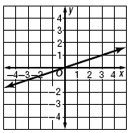
B | 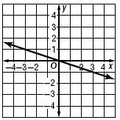
C | 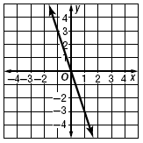
D | 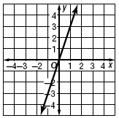

- What is the solution of the equation 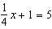?

A | 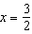
B
C
D

- What is the solution of the equation 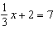?

A
B | 3
C | 15
D | 27

- Admission to Grey Fossil Museum is $7 for each child. A school group paid $161 in admission for the children. Which equation can be solved to find the number of children in the group?

A | 161 = 7 – x
B | 161 = 7x
C | 161 = x – 7
D | 161 = x + 7

- Delmar bought some food, which has Tennessee state sales tax of 5%, and a $3.99 paperback book, which is taxed at 7%. He spent $16.48 in all. Which equation can be solved to find how much he spent on food?

A | 1.07(3.99) + 1.05x = 16.48
B | 1.07x + 1.05(3.99) = 16.48
C | 1.07x + 1.05(3.99) = 16.48
D | 0.07(3.99) + 0.05x = 16.48

- A tomato plant is 5 inches tall. Assuming the plant grows 3 inches every week, how tall will the seedling be in 4 weeks?

A | 17 in.
B | 12 in.
C | 9 in.
D | 8 in.

- A puppy weighs 15 ounces at birth. Assuming the puppy gains 9 ounces every week, how much will the puppy weigh in 4 weeks?

A | 19 ounces
B | 24 ounces
C | 36 ounces
D | 51 ounces

- A young tree is 3.5 feet tall. Assuming the tree grows 0.2 foot per month, how much taller will the tree be in 6 months?

A | 3.7 feet
B | 4.1 feet
C | 4.7 feet
D | 9.5 feet

