TCAP Blitz Assessment – 8th Grade
Week 3

- Leonard is staying at a hotel in Dickson that is located miles from where his friend lives in Burns. Which shows the location of on the number line?

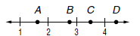

A | Point A
B | Point B
C | Point C
D | Point D

- Which point represents ?

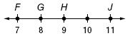

A | Point F
B | Point G
C | Point H
D | Point J

- Which best describes the value of (8.4)²?

A | greater than 8 and less than 16
B | greater than 16 and less than 64
C | greater than 32 and less than 64
D | greater than 64 and less than 81

- Which of the following numbers is rational?

A | π
B
C
D

- Which statement about the list of values shown below is true?

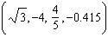

A | Only –0.415 is irrational.
B | Only –4 is rational.
C | Only and are irrational.
D | Only is rational.

- Simplify:

A
B
C
D

- Simplify: 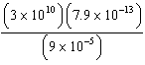

A
B
C
D

- The table below shows the number of widgets produced in 2008 and 2009.

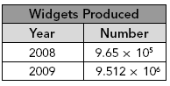

How many more widgets were produced in 2009 than in 2008?

A
B
C
D

- If one light year is approximately miles, how many miles is 500 light years?

A
B
C
D

- Elena has two cultures of bacteria. She estimates that the number of bacteria has grown to in the first culture and in the second culture. About how many bacteria exist in the two cultures?

A
B
C
D

