TCAP Blitz Assessment – 8th Grade
Week 5

- What is the length of h in the triangle shown below?

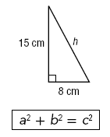

A | 7 cm
B | 12.7 cm
C | 17 cm
D | 23 cm

- Point D is the midpoint of . What is the length of ?

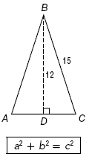

A
B | 18
C | 9
D | 6

- Vidal drove due south 146 miles from Lexington to Knoxville. He then turned due west and drove 159 miles to Nashville. About how far is the straight-line distance from Lexington to Nashville?

A | 146 miles
B | 159 miles
C | 216 miles
D | 305 miles

- The figure below shows the tent that Vonda’s scout troop will sleep in when they go camping. How wide is the bottom front of the tent?

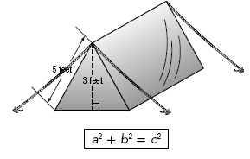

A | 4 feet
B | 5 feet
C | 6 feet
D | 8 feet

- Lines a and b are parallel. If the measure of ∠3 is 56°, what is the measure of ∠8?

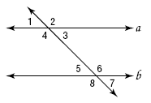

A | 34°
B | 56°
C | 124°
D | 146°

- In the figure below, what is the measure of ∠5 if the measure of ∠1 is 62°?

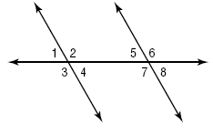

A | 152°
B | 118°
C | 62°
D | 28°

- The scatter plot on the grid below shows the relationship between the free throws taken in a game and the total points scored during that game.

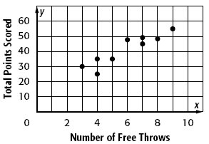

Which of the following lines best fits the scatter plot?

A | y = 5x + 15
B | y = 40
C | y = 5x + 55
D | y = 3x + 10

- What type of correlation can be seen in the scatterplot below?

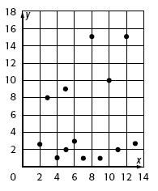

A | strong positive linear relationship
B | weak positive linear relationship
C | strong negative linear relationship
D | There is no evidence of a positive or negative linear relationship.

- A magazine has published a table with the 2008–2009 financial aid profile for the University of Tennessee. Which of the following conclusions shows how the information in this table may be misleading?

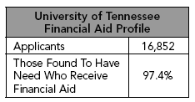

A | The table does not show the number of students who did not apply for financial aid.
B | The table does not show how many applicants were found to have financial need.
C | The table does not show whether students are freshman or not.
D | The table does not compare its statistics to other years.

- In a survey, students were asked if they would like to have longer school days if they could have a longer summer vacation. Eighty-five percent of the students surveyed said “yes,” while fifteen percent of the students surveyed said “no.” The question and circle graph below are the published results of the survey. What is misleading about these results?

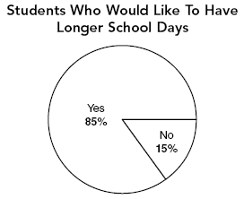

A | The graph does not show who is being surveyed.
B | The segments of the graph are not to scale.
C | The question only addresses part of the topic.
D | The question is not objective.

