6th Grade Common Assessment #2

- Julia purchased several boxes of cereal. The table below shows the weight of each kind of cereal she bought.

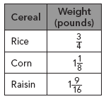

What is the total weight of the cereal that Julia bought?

- pounds
- pounds
- pounds
- pound

- Adriana lives 9 miles from the mall. Two of her friends live along the way to the mall. She drives miles to pick up one friend and then the two of them drive another miles to pick up the second friend. After picking up her two friends, how much farther does she need to drive before she reaches the mall?

- miles
- miles
- miles
- miles

- The 1991 edition of the Tennessee Code Annotated divided Tennessee into its current three grand divisions. The number of counties in each division is shown on the table below.

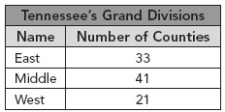

What is the ratio of counties in West Tennessee to counties in East Tennessee?

- The ratio of walkers to bikers on a trail is about 10 to 6. If there are 20 walkers, about how many bikers would there be?

- 10
- 12
- 25
- 60

- Larry takes a typing test. The table below lists his results for a sample test of 100 words.

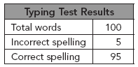

At this rate, how many words can Larry be expected to type incorrectly on an 800-word paper?

- 40
- 160
- 400
- 760
- Dave is starting a business mowing lawns.
Which of the following expresses a rate he could charge for mowing lawns?
A. | four houses out of 20 houses
B. | 45 minutes per hour
C. | fifteen dollars per lawn
D. | two days per week
- What is the ratio of stripes to stars on the flag below?
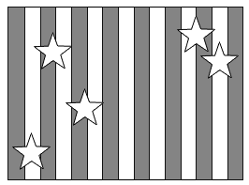
- 1:3
- 2:3
- 3:2
- 3:1

- The Lady Tigers have played 13 games this year and have won 6. What is the ratio of their wins to losses?
- $\frac{6}{7 }$
- $\frac{6}{13}$
- $\frac{7}{6}$
- $\frac{13}{7}$

- If 3 pounds of pears costs $2.70, how much will 10 pounds cost?
- $0.90
- $5.40
- $8.10
- $9.00

- If 3 notebooks cost $3.51, how much would 7 notebooks cost?
- $5.98
- $24.57
- $8.02
- $8.19

Constructed Response

Demonstrate your knowledge by giving a clear, concise solution to each problem. Be sure to include all relevant drawings and justify your answers. You may show your solution in more than one way or investigate beyond the requirements of the problem.

a. Tell in your own words the meaning of ratio.
b. Give an example of a ratio. Show the ratio in three ways.

6th Grade Common Assessment #2
Answer Key
Question Number | Answer | Skill Number
1 | D | SPI 0606.2.4 Solve multi-step arithmetic problems using fractions, mixed numbers, and decimals
2 | B | SPI 0606.2.4 Solve multi-step arithmetic problems using fractions, mixed numbers, and decimals
3 | A | SPI 0606.2.6 Solve problems involving ratios, rates and percents
4 | B | SPI 0606.2.6 Solve problems involving ratios, rates and percents
5 | A | SPI 0606.2.6 Solve problems involving ratios, rates and percents
6 | C | SPI 0606.2.6 Solve problems involving ratios, rates and percents
7 | D | SPI 0606.2.6 Solve problems involving ratios, rates and percents
8 | A | SPI 0606.2.6 Solve problems involving ratios, rates and percents
9 | D | SPI 0606.2.6 Solve problems involving ratios, rates and percents
10 | D | SPI 0606.2.6 Solve problems involving ratios, rates and percents

Constructed Response
a. A ratio is the comparison of two numbers by division.
b. 3 out of 4, 3:4, 3 to 4, , ♥♥♥♦♦♦♦
Constructed Response Rubric
Score | Expectations
Full Credit (20 points) | - Your response addresses all parts of the question clearly and correctly.  - You use and label the proper math terms in your answer.  - Your response shows all the steps you took to solve the problem.
Partial Credit (15 points) | - Your response addresses most parts of the question correctly.  - Your response does not show all of your work or does not completely explain the steps you took to solve the problem.
Minimal Credit (10 points) | - Your response addresses only one part of the question correctly and explains the steps you took to solve that one part. In answering the remaining parts of the question, your response is incomplete or incorrect.  - Your response does not show all of your work or does not explain all of the steps you took to solve the problem
No Credit (0 points) | - Your response is incorrect.

