8th Grade Common Assessment #2

- The graph shows the total cost C to buy b bananas. Which equation represents the relationship shown in the graph?

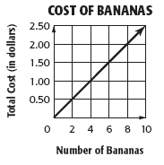

- C = 0.25b
- C = 0.50b
- C = 2.00b
- C = 2.50b

- Which equation is shown on the graph below?

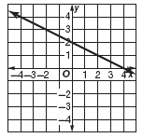

- 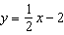
- 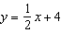
- 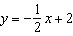
- 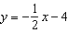

- What equation represents the line shown in the graph?

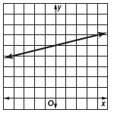

- 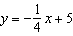
- 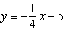
- 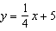
- 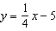

- Which equation describes the relationship between the corresponding values of x and y shown in the table?

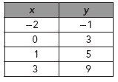

- y = x + 1
- y = 2x – 3
- y = 2x + 3
- y = 3x + 5

- The line segment on the graph shows the distance traveled by a sightseeing trolley during one minute of its route. Which of the following best describes the slope of the line segment?

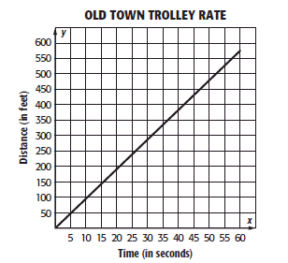

- The trolley travels at a rate of 29.5 feet per second.
- The trolley travels at a rate of 19.5 feet per second.
- The trolley travels at a rate of 9.5 feet per second.
- The trolley travels at a rate of 5.5 feet per second.

- The graph below shows the height of a gondola that brings hikers down a mountain with respect to time.

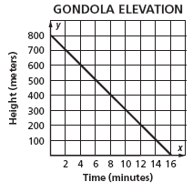

Which statement best interprets the slope of the graph?

- The height of the gondola changes at a rate of 100 meters per minute.
- The height of the gondola changes at a rate of 50 meters per minute.
- The height of the gondola changes at a rate of 16 meters per minute.
- The height of the gondola changes at a rate of 2 meters per minute.

- What is the slope of the line that contains points (7, 8) and (15, 30)?

- The graph shows what a salesperson will earn while working at the warehouse. The x-axis represents the number of units sold and the y-axis represents earnings.

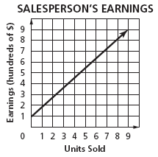

Which statement best interprets the y-intercept in the graph?

- Mr. Stimson earns $100 when he sells 1 unit.
- Ms. Satorelli earns no money even if she sells 1 unit.
- Ms. Amarova earns no income when she sells 0 units.
- Mr. Singh earns $100 even if he sells 0 units.

- The graph shows the cost C of hiring a plumber for x hours. What does the point (2, 100) on the graph indicate?

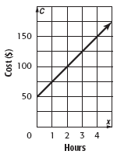

- The plumber charges $50 per hour.
- The service charge for the plumber is $100.
- The plumber charges $100 for 2 hours.
- The plumber charges twice as much for 2 hours as for 1 hour.

- Which of the following ordered pairs is a solution of the equation represented by the line shown on the graph?

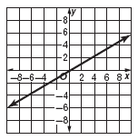

- (4, 7)
- (7, 4)
- (6, –2)
- (–2, 6)

Constructed Response
Demonstrate your knowledge by giving a clear, concise solution to each problem. Be sure to include all relevant drawings and justify your answers. You may show your solution in more than one way or investigate beyond the requirements of the problem.

- Steven used the graph above to track the weight gain of his new puppy. He believes that his puppy gains weight at a rate of 2 pound per week. Is he correct? Defend your response using equations, tables, drawings, and/or words.

- Charles wants to determine how soon the puppy will weigh 20 pounds. Given that the puppy continues to gain weight at the same constant rate, how many weeks will pass before the puppy weighs 20 pounds?

8th Grade Common Assessment #2
Answer Key

Question Number | Answer | Skill Number
1 | A | SPI 0806.3.4 Translate between various representations of a linear function
2 | C | SPI 0806.3.4 Translate between various representations of a linear function
3 | C | SPI 0806.3.4 Translate between various representations of a linear function
4 | C | SPI 0806.3.4 Translate between various representations of a linear function
5 | C | SPI 0806.3.5 Determine the slope of a line from an equation, two given points, a table or a graph
6 | B | SPI 0806.3.5 Determine the slope of a line from an equation, two given points, a table or a graph
7 | A | SPI 0806.3.5 Determine the slope of a line from an equation, two given points, a table or a graph
8 | D | SPI 0806.3.6 Analyze the graph of a linear function to find solutions and intercepts
9 | A | SPI 0806.3.6 Analyze the graph of a linear function to find solutions and intercepts
10 | B | SPI 0806.3.6 Analyze the graph of a linear function to find solutions and intercepts

Constructed Response
Answer Key
- Steven is not correct. The graph shows that his puppy gains 4 pounds each week. This can be shown using the equation y = 4x.
- Charles can use the equation y = 4x, where y represents the weight and x represents the weeks. 20 = 4x; x = 5. So, 5 weeks will pass before the puppy weighs 20 pounds.
Constructed Response Rubric
Score | Expectations
Full Credit (20 points) | - Your response addresses all parts of the question clearly and correctly.  - You use and label the proper math terms in your answer.  - Your response shows all the steps you took to solve the problem.
Partial Credit (15 points) | - Your response addresses most parts of the question correctly.  - Your response does not show all of your work or does not completely explain the steps you took to solve the problem.
Minimal Credit (10 points) | - Your response addresses only one part of the question correctly and explains the steps you took to solve that one part. In answering the remaining parts of the question, your response is incomplete or incorrect.  - Your response does not show all of your work or does not explain all of the steps you took to solve the problem
No Credit (0 points) | - Your response is incorrect.

