TCAP Blitz Assessment – 6th Grade

- The results of a survey are shown on the bar graph below.

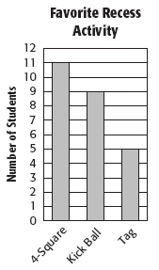

If 100 students were surveyed, how many students could be predicted to choose kick ball as their favorite recess activity?

A | 9
B | 20
C | 36
D | 44

- The ratio of pepperoni pizza slices to mushroom pizza slices sold at the cafeteria is 7 to 3. Suppose the cafeteria staff predicts they will sell 00 slices of pizza next Friday. How many of them should be pepperoni?

A | 140
B | 146
C | 150
D | 155

- Before he solved the problem below, Jerome estimated that the product of the numbers was 6.

3.75 × 2.19

Which of the statements about his estimate is true?

A | His estimate is too high.
B | His estimate is too low.
C | His estimate is reasonable.
D | His estimate should have been 9.

- Look at the table below.

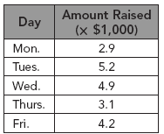

Which of the following is the best estimate of the amount of money raised during the 5-day fundraiser?

A | $15,000
B | $18,000
C | $20,000
D | $22,000

- Which situation could the integer –33 be used to describe?

A | a gain of 33 yards
B | a loss of 33 pounds
C | a height of 33 feet above sea level
D | a deposit of 33 dollars

- Tennessee is divided into 6 regions. One of the regions, the Blue Ridge, has an average elevation of 5,000 feet above sea level. Which integer best represents this elevation?

A | –5,000
B | –6
C | 6
D | 5,000

- Which equation best represents the distributive property?

A | a(b + c) = (a × b) + (a × c)
B | a(b + c) = (a + b) × (a + c)
C | a(b + c) = (a + b) + (a + c)
D | a(b + c) = (a × b) × (a × c)

- Which equation represents the associative property?

A | 5 × (6 × 7) = (5 × 6) + 7
B | 5 × (6 × 7) = (5 × 6) × 7
C | 5 × (6 × 7) = (5 × 6) + (5 × 7)
D | 5 × (6 × 7) = (6 × 7) × 5

- Look at the key.

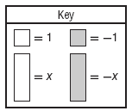

Which model best represents the expression 6x + (–2)?

A | 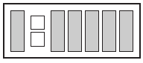
B | 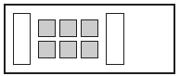
C | 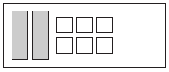
D | 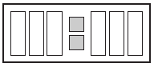

- Look at the key.

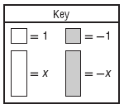

Which model best represents the expression –3x + 2?

A | 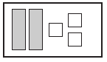
B | 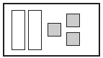
C | 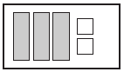
D | 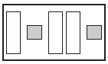

- Maundu emptied half of the contents of a full bag of paper clips. The full bag weighed pound. What does it weigh now?

A | pounds
B | pounds
C | 1 pounds
D | pounds

- Richard has eaten of a pizza. His friend comes over and eats of the remaining pizza. How much of the whole pizza did Richard’s friend eat?

A
B
C
D

- A basketball player played minutes during the first half of a game and minutes during the second half of the game. How many more minutes did he play in the second half than in the first half?

A
B
C
D

- The area of a room can be found by multiplying its length by its width. What is the area of a room that is feet long by feet wide?

A | 195 ft²
B | 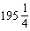 ft²
C | 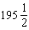 ft²
D | 196 ft²

- A candy store has 15.75 pounds of candy. They sell the candy in 2.25-pound boxes. How many boxes of candy can they sell?

A | 6 boxes
B | 7 boxes
C | 18 boxes
D | 35 boxes

- Diane has two beagles. One of her beagles weighs 29.75 pounds and the other weighs 38.9 pounds. What is the combined weight of her two beagles?

A | 67.65 pounds
B | 67.84 pounds
C | 68.65 pounds
D | 68.84 pounds

- What is the value of the expression below?

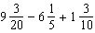

A
B
C | 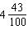
D

- Karen has yards of rope. She needs 4 pieces each yards long. After cutting off those 4 pieces, how many additional pieces yards long could she cut from the remaining length of rope?

A | 2
B | 3
C | 4
D | 5

- The firefly or lightning bug is the Tennessee state insect. A single firefly has a brightness of of a candle. What is as a decimal?

A | 0.025
B | 0.25
C | 2.5
D | 40

- In 2008, about 23.8% of the people in Tennessee were under 18 years old. What is 23.8% as a decimal?

A | 0.238
B | 2.38
C | 23.8
D | 238

- Use the road sign below.

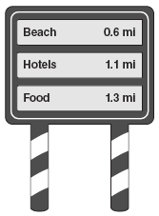

How far away are the hotels? Express your answer in fractional form.

A | mi
B | mi
C | mi
D | mi

- Roger went on a trip. He spent 20% of his money on gasoline. If he spent $815 on his trip, how much did he spend on gasoline?

A | $143
B | $160
C | $163
D | $166

- Delicia and Safara are both writing novels, but Safara is a faster writer than Delicia is. In the time that it takes Safara to write 5 pages, Delicia can write 3 pages. If they keep up the same rate, how many pages can Delicia write in the time that it takes Safara to write 60 pages?

A | 18
B | 36
C | 72
D | 100

- The number of games won and lost by the Tennessee Titans from 2006 to 2009 are shown in the table below.

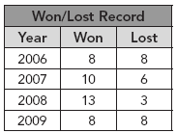

What is the ratio of games won to games played from 2006 to 2009?

A
B
C
D

- Which graph best shows the location of Point P at 2.8 on the number line?

A | 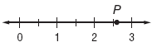
B | 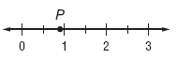
C | 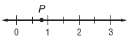
D | 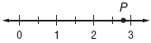

- Ricardo is graphing points on the number line below.

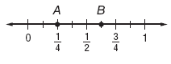

Which value could be graphed between points A and B?

A | 0.22
B | 0.33
C | 0.71
D | 0.85

- During a flood, a river reached a point 21 feet above flood stage. Which number line best shows Point K at 21?

A | 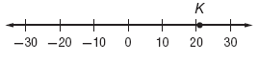
B | 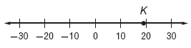
C | 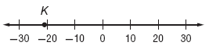
D | 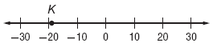

- Lance withdrew $25 from his checking account. Which graph best shows Point W representing the integer –25?

A | 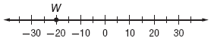
B | 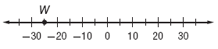
C | 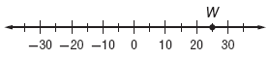
D | 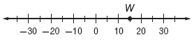

- Admission to the school play is $5 per student. The total amount of money made from ticket sales is $2,500. Which equation can be used to determine s, the number of students who saw the play?

A
B
C
D | 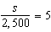

- Stephan bought 3 boxes of ink cartridges for his printer. There are 12 cartridges in each box. Stephan used all but 8 of the cartridges. Which equation can be used to find c, the number of cartridges that Stephan used?

A | c = (3 × 12) – 8
B | c = 3 × 12 – 8 × 12
C | c = 3 × 12
D | c = 3 × (12 – 4)

- The Pyramid Arena in Memphis is the third largest pyramid in the world. Its height in stories can be found by writing and solving an equation.

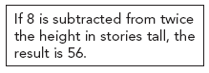

Which of the following equations could be used to find p, the height of the Pyramid Arena in stories?

A | 2(p – 8) = 56
B | 2p – 8 = 56
C | 2(p + 8) = 56
D | 2p + 8 = 56

- What is 3g + 6(g – 5) in simplified form?

A | 9g – 5
B | 3g + 1
C | 9g – 30
D | 4g

- Which of the following shows another way of writing the expression below?

(y × 6) + (4 × 6) + y

A | 7y + 24
B | 24 + y
C | 6y + 24
D | 31y

- Which equation best represents the situation below?

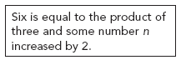

A | 6 = 3 2 + n
B | 6 = 3n + 2
C | 2 = 3n + 6
D | 3 = 2n + 6

- Which algebraic expression is equivalent to “the product of 75 and the quotient of 6 and x”?

A
B
C | 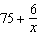
D | 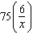

- Which phrase is the best represents the algebraic expression below?

14 – n

A | scored 14 less points than n
B | scored n fewer points than 14
C | scored 14 times as many points as n
D | scored n more points than 14

- Jada needed to solve a problem that read 4 times the sum of a number x and 8 is equal to 48. To solve the problem, she wrote the equation below.

4(x + 8) = 48

Which value will make the equation true?

A | 20
B | 14
C | 10
D | 4

- What value of m makes the equation true?

11m + 33 = 132

A | 9
B | 11
C | 12
D | 13

- Which point has coordinates of (–4, 0)?

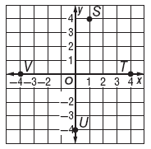

A | Point S
B | Point T
C | Point U
D | Point V

- What are the coordinates of Point F?

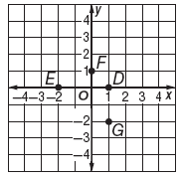

A | (–2, 0)
B | (1, 0)
C | (0, 1)
D | (1, –2)

- What is the measure of the missing exterior angle in the triangle below?

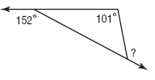

A | 28°
B | 51°
C | 120°
D | 129°

- What is the measure of exterior angle B in the figure below?

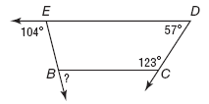

A | 74°
B | 75°
C | 76°
D | 104°

- A lamp has a base with a diameter of 9 inches.

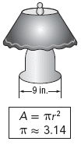

What is the area of the bottom of the base of the lamp?

A | 28.26 in²
B | 56.52 in²
C | 63.59 in²
D | 254.34 in²

- What is the circumference of the circle shown below?

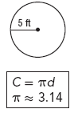

A | 10.56 ft
B | 15.7 ft
C | 30.25 ft
D | 31.4 ft

- The cylinder below is made of cardboard.

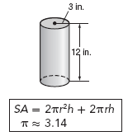

What is the surface area of the cardboard cylinder?

A | 282.60 in²
B | 452.16 in²
C | 678.24 in²
D | 904.32 in²

- Alexius drew the picture shown below during math class. What is the volume of Alexius’ triangular prism?

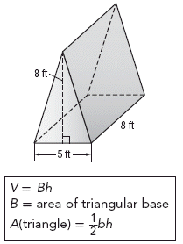

A | 40 ft²
B | 80 ft²
C | 160 ft²
D | 320 ft²

- Bai researched what the cost of school basketball tickets were over a four-year period. She displayed her results in a bar graph.

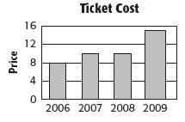

What is misleading about this graph?

A | Price cannot be compared to years.
B | The y-axis is in increments of 4.
C | The bar for 2009 is wider than the other bars.
D | The x-axis should also be in increments of 4.

- The line graph below shows the change in temperature from 12 P.M. to 4 P.M.

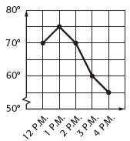

What feature of the graph may be misleading?

A | There is a break in the horizontal axis.
B | The vertical axis scale is inconsistent.
C | There is a break in the vertical axis.
D | The horizontal axis scale is too large.

- A community theater would like to find out whether to add more comedy or drama to their repertoire to broaden their audience. Members of the board decided to run a survey to decide what people preferred. Which sample would be best to make sure their survey is not biased?

A | surveying those who donate to the arts
B | surveying all season ticket holders
C | surveying a random sample of community members
D | surveying community members who live close to the theater

- Deja wants to know who is going to win the election for school president. She surveys friends of one of the candidates to find out whom they think will win the election. Why might this be a biased survey?

A | The sample included only those who were voting in the election.
B | The sample included everyone at the school.
C | The survey only included friends of one candidate.
D | The survey only included the candidates.

