TCAP Blitz Assessment – 6th Grade
Weeks 3 – 4

- Which question can the equation n = 12 × 12 × 15 answer?

A What is the area of a triangle that has a base of 12 centimeters and height of 15 centimeters?
B What is the volume of a rectangular prism that has a length of 12 centimeters, a width of 12 centimeters, and a height of 15 centimeters?
C What is the perimeter of a triangle that has sides of 12 centimeters, 12 centimeters, and 15 centimeters?
D What is the surface area of a triangular prism that has
a height of 12 centimeters, a length of 12
centimeters, and a width of 15 centimeters.

- Ethan is 63 inches tall. This is 7 inches less than twice the height of his younger sister Isabella. Which equation can be used to determine h, the height of Isabella?

A 7h – 2 = 63
B 2h – 7 = 63
C 2h – 7 = 63
D 7h + 2 = 63

- Which equation does the drawing below represent?

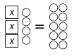

A 3x = 10
B 3x + 4 = 7x
C 3x + 4 = 10
D 4x + 3 = 10

- Raul goes to a music store to buy the items listed on the table below.

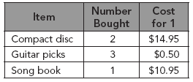

He pays for the items with a $100 bill. Which equation can be used to find m the amount of change Raul should receive?

A m = 100 – 14.95 × 0.50 × 10.95
B m = 100 – 2 × (14.95 + 0.50) × 10.95
C m = 100 – (2 × 14.95) – (3 × 0.50) – 10.95
D m = (2 × 14.95) + (3 × 0.50) + 10.95

- Which expression is equivalent to the expression below?

9(4 + y)

A 36 + 4y
B 13 × 9y
C 36 + 9y
D 54 + 6y

- A math test problem is shown below.

4(a + 5) + 2(a – 4)

What is the simplified form of this expression?

A 6a + 1
B 6a + 5
C 6a + 12
D 6a + 16

- Which expression is equivalent to the expression below?

5(a + 9)

A 14a
B 50a
C 5a + 9
D 5a + 45

- Which expression below is equivalent to
4x + 3(x + 5)?

A 4x + 8
B 5x + 15
C 7x + 5
D 7x + 15

- Which of the following has same meaning as the expression below?

8n – 2

A 2 less than the product of 8 and a number n
B the sum of 2 and the product of 8 and a number n
C the quotient of 8 and a number n less 2
D the difference in 2 and the quotient of 8 and a
number n

- What is the algebraic expression for “27 fewer than the product of 32 and t?”

A
B
C 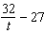
D 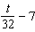

- The product of 15 and some number x is 45. Which equation shows this relationship?

A x + 15 = 45
B 45x = 15
C 15x = 45
D x – 15 = 45

- When 15 is added to the number of students in a math class, the result is 32. Which equation can be used to find h, the number of students in the math class?

A 15 + h = 32
B 15 + 32 = h
C h – 32 = 15
D 15h = 32

- Jin used the equation below to find the number of photos in an album.

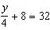

How many photos are in Jin’s album?

A 6
B 96
C 128
D 160

- The equation below can be used to find p, the number of 2-minute penalties a hockey player has if he plays 36 minutes out of a game that lasts 50 minutes.

36 + 2p = 50

Which value of p makes the equation true?

A 2
B 4
C 6
D 7

- The solution to the equation below gives the number of lakes managed by Tennessee Wildlife Resources Agency.

3x – 9 = 45

How many lakes are managed by the Tennessee Wildlife Resources?

A 8
B 12
C 15
D 18

- Heather spends a total of $600 on food to cater two events. She hopes to make a total profit of $240.

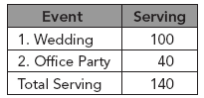

She uses the equation below to find p, the price in dollars that she needs to charge per serving.

140p – 600 = 240

How much should Heather charge per serving, in dollars?

A $5
B $6
C $7
D $8

- Kumar wants to find the location of an ordered pair. Which point best represents the location of the ordered pair (–1, –4)?

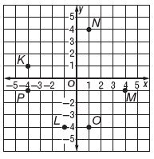

A Point K
B Point L
C Point P
D Point M

- What are the coordinates of Point N on the graph below?

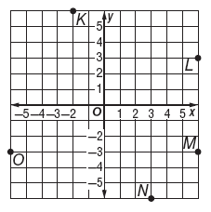

A (6, 3)
B (6, –3)
C (3, –6)
D (–6, –3)

- Which point is located at (3, 2) on the graph below?

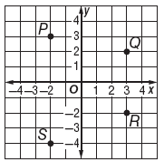

A Point P
B Point Q
C Point R
D Point S

- Which ordered pair names the location of Point T on the graph below?

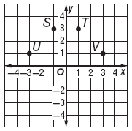

A (–3, 1)
B (–1, 3)
C (1, 3)
D (3, 1)

