TCAP Blitz Assessment 7th Grade
Week 4

- Muna mixed 2 pints of red paint with 5 pints of blue paint to make a shade of purple. Which proportion can be used to find x, the percent of blue paint in the paint mixture?

A | 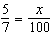
B | 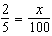
C | 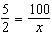
D | 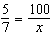

- Janine has 100 mL of a vinegar solution that is 5% salt by weight. She adds 150 mL of a vinegar solution that is 2% salt by weight. What percent salt is the resulting solution?

A | 7%
B | 6%
C | 3.5%
D | 3.2%

- Use the graph below. What is the rule for the graphed pattern?

A | y = x – 4
B | y = x + 4
C | y = –x – 4
D | y = –x + 4

- Use the table below. What is the pattern for the table?

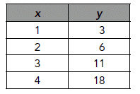

A | y = x + 2
B | y = 3x + 2
C | y = x² + 2
D | y = 2x² + 1

- Use the graph below. What is the rule for the graphed pattern?

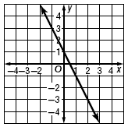

A | y = –2x – 1
B | y = –2x + 1
C | y = –x – 1
D | y = –x + 1

- The table shows the side length and volume of cubes. What type of relationship is shown?

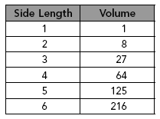

A | directly proportional
B | inversely proportional
C | linear
D | nonlinear

- What is the relationship between x and y in the table below?

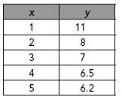

A | directly proportional
B | linear
C | inversely proportional
D | other nonlinear relationship

- Which graph models a directly proportional relationship?

A | 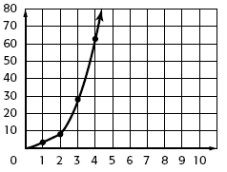
B | 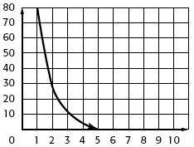
C | 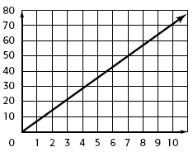
D | 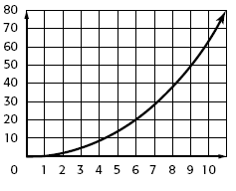

- Use the map below. Ozone is inches from Rockwood on the map. How far apart in actual distance are they?

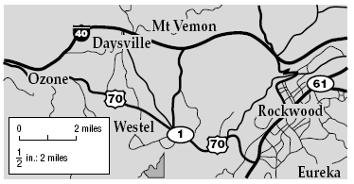

A | 2 miles
B | 4 miles
C | 6 miles
D | 8 miles

- Use the map below. Dixon Springs is 1.3 inches from Carthage on the map. How far apart are they?

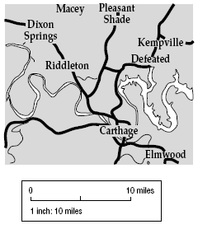

A | 26 miles
B | 19.5 miles
C | 13 miles
D | 6.5 miles

