TCAP Blitz Assessment - 8th Grade

1. Mars takes about 1.9 years to make one revolution around the Sun. How many times would Mars revolve around the Sun in 22.8 years?

A | 9
B | 10
C | 11
D | 12

2. Lourdes records the following data after riding her bike around the school track.

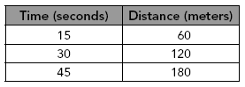

If Lourdes continues to ride at the rate shown in the table, what is the approximate distance she will bicycle in 5 minutes?

F | 900 meters
G | 1050 meters
H | 1200 meters
J | 1350 meters

3. The distance from Jerud’s home near Nashville to his college in Memphis along I-40 is about 200 miles. If Jerud drives from his home to Memphis at an average rate of 65 miles per hour, about how long will the trip take?

A | about 3 hours
B | about 3.3 hours
C | about 3.5 hours
D | about 4 hours

4. The graph below shows the handling fee a company charges based on the weight of the package.

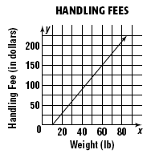

According to the graph, which of the following statements is true?

F | A package that weighs less than 10 pounds has a $10 handling fee.
G | The handling fee increases $1 for every 10 pounds.
H | The handling fee increases $10 for every 1 pound.
J | There is no handling fee for packages that weigh 10 pounds or less.

5. Which does the following graph represent?

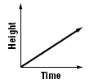

A | As time decreases, height remains constant.
B | As time decreases, height increases.
C | As time increases, height decreases.
D | As time increases, height increases.

6. A car travels at a constant speed, then gradually slows down as it approaches a stop sign, and then stops. Which graph best represents the speed the car travels during this time?

F | 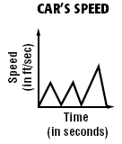
G | 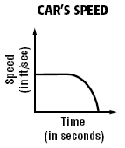
H | 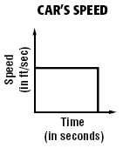
J | 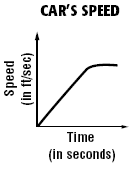

7. Adrianna is shopping for roasted almonds for the company’s holiday party. She looks at several wholesale stores. Which store has the best buy for almonds?

A | Wholesale Club sells a 5-pound bag for $29.95
B | Gary’s Foods sells a 7.5-pound bag for $41.25.
C | Whole Traders sells a 4-pound bag for $21.
D | Food Club sells a 1-pound bag for $6.25.

8. Which of the following is the best buy for ground beef?

F | 5 lbs. for $8.95
G | 3 lbs. for $5.55
H | 6 lbs. for $10.80
J | $2.49 per pound

9. Which best describes the value of (4.5)²?

A | Greater than 4 and less than 9
B | Greater than 9 and less than 16
C | Greater than 16 and less than 25
D | Greater than 25

10. A carpenter determines the length of a beam to be feet. Between which two integers does this length lie on a number line?

F | between 6 and 7
G | between 7 and 8
H | between 8 and 9
J | between 9 and 10

11. The table shows the approximate portion of Tennessee’s manufacturing economy that is made up of different industries. Which of the following shows the portions in order from least to greatest?

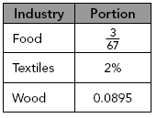

A | 2%, , 0.0895
B | 2%, 0.0895,
C | 0.0895, 2%,
D | , 0.0895, 2%

12. A design engineer calculates the distance between two bolts to be inches. Between which two integers does this length lie on a number line?

F | between 2 and 3 inches
G | between 3 and 4 inches
H | between 4 and 5 inches
J | between 5 and 6 inches

13. Which of the following numbers is rational?

A | 3.1212 ...
B | 3.12123 ...
C | 3.14592 ...
D | π

14. Which of the following numbers is rational?

F
G
H
J

15. Which of the following numbers is rational?

A
B
C
D

16. Which expression can be used to find the product of and ?

F
G
H
J

17. Simplify .

A
B
C
D

18. Simplify: 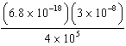

F
G
H
J

19. In 1998, the Tennessee government collected about dollars in tax revenue. In 2008, the Tennessee government collected about dollars in tax revenue. How much more did they collect in 2008 than in 1998?

A
B
C
D

20. In 2008, the population in Tennessee was about . The population of California was . About how many more people did California have than Tennessee in 2008?

F
G
H
J

21. In 2006, Tennessee’s total population was approximately . If 12.4% of the population was over the age of 65, about how many people in Tennessee were over 65 in 2006?

A
B
C
D

22. What is the solution to this system of equations?

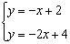

F | (1, 1)
G | (2, 0)
H | (0, 2)
J | There is no solution.

23. What is the solution to the system of equations shown below?

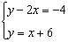

A | (16, 10)
B | (10, 16)
C | (–10, 4)
D | (–10, –24)

24. What is the solution to this system of equations?

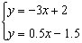

F | (1, –1)
G | (–1, 1)
H | (3, 0)
J | (0, 2)

25. Given 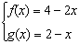
What is the value of x if .

A | –2
B | 0
C | 2
D | 4

26. Given: 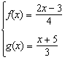
What is the value of x if ?

F | –29
G
H
J | 29

27. Given: 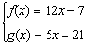
What is the value of x if ?

A | –4
B
C
D | 4

28. Which of the following graphs represents the function 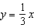?

F | 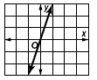
G | 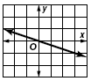
H | 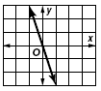
J | 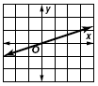

29. Which graph best represents the table of values below?

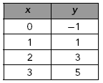

A | 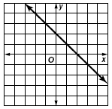
B | 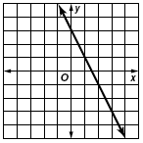
C | 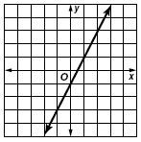
D | 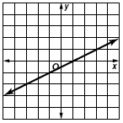

30. Which expression can be used to find the value of g(n) in the table below?

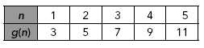

F | 4n – 1
G | 3n
H | 2n – 1
J | 2n + 1

31. What is the equation of the linear function shown below?

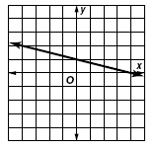

A
B | 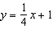
C
D | 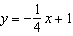

32. Which of the following best describes the slope of the line?

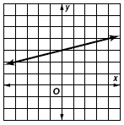

F | The slope of the line is .
G | The slope of the line is .
H | The slope of the line is 2.
J | The slope of the line is 4.

33. What is the slope of the line that passes through the points (3, 6) and (–5, 2)?

A | –2
B
C
D | 2

34. What is the slope of the linear function shown in the graph?

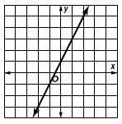

F | –2
G | –1
H | 1
J | 2

35. Where is the x-intercept of the function graphed below located?

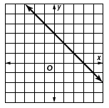

A | (3, 0)
B | (0, 3)
C | (3, 3)
D | (0, 0)

36. At what points can you find the x- and y-intercepts of the function graphed below?

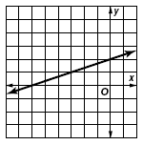

F | (0, –6) and (0, 2)
G | (0, –6) and (2, 0)
H | (–6, 0) and (0, 2)
J | (–6, 0) and (2, 6)

37. Which of the following ordered pairs is a solution for the linear function shown below?

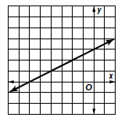

A | (0, –6)
B | (–3, 0)
C | (2, –2)
D | (–2, 2)

38. Which of the following functions is linear?

F | y = 3x(x + 4)
G | 3x² – y = 16
H | 2x² – 5 = y
J | 4x + 5y = –12

39. Which of the following equations is linear?

A
B
C
D

40. Which equation is nonlinear?

F
G
H
J

41. If the two legs of a right triangle measure 7 cm and 9 cm, what is the approximate length of the hypotenuse?

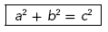

A | 14 cm
B | 11.4 cm
C | 9.1 cm
D | 5.7 cm

42. For which triangle is the relationship true?

F | 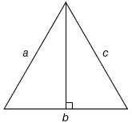
G | 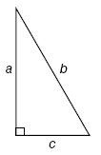
H | 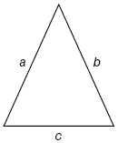
J | 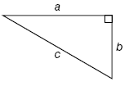

43. In the figure below, what is the value of x to the nearest tenth?

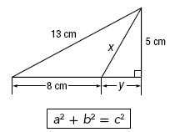

A | 6.4 cm
B | 12.8 cm
C | 14.5 cm
D | 17.7 cm

44. The AT&T building in Nashville is the tallest building in Tennessee. Use the figure below. What is the height of the building? Round your answer to the nearest whole meter.

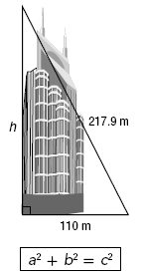

F | 108 m
G | 188 m
H | 244 m
J | 328 m

45. A ladder is leaning against a house as shown below.

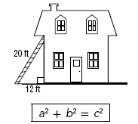

At what height on the house does the ladder reach?

A | 2.8 feet
B | 8 feet
C | 16 feet
D | 23.3 feet

46. How high up the wall does the ladder reach?

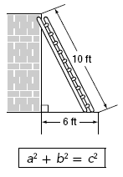

F | 6.5 ft
G | 7 ft
H | 7.5 ft
J | 8 ft

47. In the figure below, what is the measure of if the measure of is 48°?

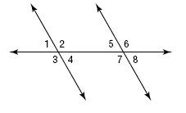

A | 138°
B | 132°
C | 48°
D | 42°

48. Lines m and n are parallel. Both lines are cut by transversals a and b.

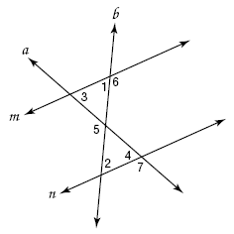

Which statement is not a valid conclusion?

F
G
H
J

49. In the figure, two parallel lines are cut by a transversal. What is the measure of is the measure of is 121°?

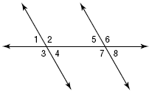

A | 149°
B | 121°
C | 59°
D | 31°

50. Which statement best describes the relationship shown on the scatter plot?

F | As price increases, demand decreases.
G | As price increases, demand increases.
H | As demand decreases, price decreases.
J | There is no relationship between price and demand.

51. The line of best fit for the profits of a 5-year old company is shown in the scatter plot below.

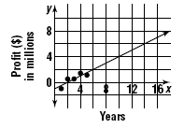

By the end of its eighth year, how much profit should the company expect to make?

A | $3 million
B | $5 million
C | $7 million
D | $18 million

52. The scatter plot below shows the high school and college grade point averages of 7 students. Which of the following describes the data presented?

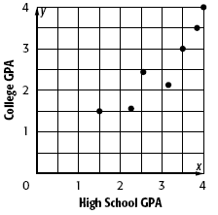

F | A student’s high school GPA is usually similar to their college GPA.
G | A student’s high school GPA is usually equal to their college GPA.
H | A student’s high school GPA does not usually affect their college GPA.
J | A student’s high school GPA is usually much higher than their college GPA.

53. The bar graph below shows the results of a survey on the favorite type of pet among eighth graders. Which of the following best explains why the graph might be considered misleading?

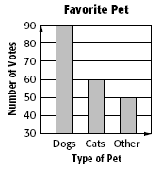

A | The title is misleading.
B | The vertical axis does not begin at 0.
C | The horizontal axis should include more types of pets.
D | The scale on the vertical axis is too large.

54. The table below shows the average annual pay by industry.

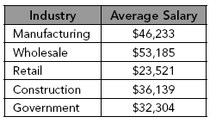

Which of the following conclusions is invalid based on the information?

F | The average wholesale salary is more than 2 times the average retail salary.
G | The average construction salary is more than 75% of the average manufacturing salary.
H | The average government salary is less than 60% of the average wholesale salary.
J | The average construction salary is less than the overall average salary.

TCAP Blitz Assessment - 8th Grade
Answer Section

1. ANS: D PTS: 1 STA: SPI 0806.1.1

2. ANS: H PTS: 1 STA: SPI 0806.1.1

3. ANS: A PTS: 1 STA: SPI 0806.1.1

4. ANS: J PTS: 1 STA: SPI 0806.1.2

5. ANS: D PTS: 1 STA: SPI 0806.1.2

6. ANS: G PTS: 1 STA: SPI 0806.1.2

7. ANS: C PTS: 1 STA: SPI 0806.1.3

8. ANS: F PTS: 1 STA: SPI 0806.1.3

9. ANS: C PTS: 1 STA: SPI 0806.2.1

10. ANS: F PTS: 1 STA: SPI 0806.2.1

11. ANS: A PTS: 1 STA: SPI 0806.2.1

12. ANS: H PTS: 1 STA: SPI 0806.2.1

13. ANS: A PTS: 1 STA: SPI 0806.2.2

14. ANS: H PTS: 1 STA: SPI 0806.2.2

15. ANS: B PTS: 1 STA: SPI 0806.2.2

16. ANS: H PTS: 1 STA: SPI 0806.2.3

17. ANS: D PTS: 1 STA: SPI 0806.2.3

18. ANS: F PTS: 1 STA: SPI 0806.2.3

19. ANS: C PTS: 1 STA: SPI 0806.2.4

20. ANS: J PTS: 1 STA: SPI 0806.2.4

21. ANS: C PTS: 1 STA: SPI 0806.2.4

22. ANS: G PTS: 1 STA: SPI 0806.3.1

23. ANS: B PTS: 1 STA: SPI 0806.3.1

24. ANS: F PTS: 1 STA: SPI 0806.3.1

25. ANS: C PTS: 1 STA: SPI 0806.3.2

26. ANS: H PTS: 1 STA: SPI 0806.3.2

27. ANS: D PTS: 1 STA: SPI 0806.3.2

28. ANS: J PTS: 1 STA: SPI 0806.3.4

29. ANS: C PTS: 1 STA: SPI 0806.3.4

30. ANS: J PTS: 1 STA: SPI 0806.3.4

31. ANS: D PTS: 1 STA: SPI 0806.3.4

32. ANS: F PTS: 1 STA: SPI 0806.3.5

33. ANS: C PTS: 1 STA: SPI 0806.3.5

34. ANS: J PTS: 1 STA: SPI 0806.3.5

35. ANS: A PTS: 1 STA: SPI 0806.3.6

36. ANS: H PTS: 1 STA: SPI 0806.3.6

37. ANS: D PTS: 1 STA: SPI 0806.3.6

38. ANS: J PTS: 1 STA: SPI 0806.3.7

39. ANS: D PTS: 1 STA: SPI 0806.3.7

40. ANS: H PTS: 1 STA: SPI 0806.3.7

41. ANS: B PTS: 1 STA: SPI 0806.4.1

42. ANS: J PTS: 1 STA: SPI 0806.4.1

43. ANS: A PTS: 1 STA: SPI 0806.4.1

44. ANS: G PTS: 1 STA: SPI 0806.4.2

45. ANS: C PTS: 1 STA: SPI 0806.4.2

46. ANS: J PTS: 1 STA: SPI 0806.4.2

47. ANS: C PTS: 1 STA: SPI 0806.4.3

48. ANS: J PTS: 1 STA: SPI 0806.4.3

49. ANS: B PTS: 1 STA: SPI 0806.4.3

50. ANS: F PTS: 1 STA: SPI 0806.5.3

51. ANS: A PTS: 1 STA: SPI 0806.5.3

52. ANS: F PTS: 1 STA: SPI 0806.5.3

53. ANS: B PTS: 1 STA: SPI 0806.5.4

54. ANS: H PTS: 1 STA: SPI 0806.5.4

