TCAP Blitz Assessment – 8th Grade
Week 4

- An airplane flying at an altitude of 40,000 feet descends at a rate of 1,500 feet per minute. If the plane descends for 10 minutes, what will be its altitude?

A | 10,000 feet
B | 12,500 feet
C | 15,000 feet
D | 25,000 feet

- Sasha drove 210 miles from Nashville to Memphis on Interstate 40. The trip took her 3 hours and 45 minutes. Assuming she maintained a constant speed, about how fast was Sasha driving?

A | 56 miles per hour
B | 58 miles per hour
C | 63 miles per hour
D | 69 miles per hour

- A train traveled approximately 66 feet per second. At that rate, how many seconds would it take the train to travel 163,680 feet?

A | 2,480 seconds
B | 2,728 seconds
C | 13,640 seconds
D | 163,746 seconds

- Kofi leaves Chattanooga at 11:00 A.M. If he drives at an average speed of 62 miles per hour, how far has he traveled when he stops for gas at 2:30 P.M.?

A | 124 miles
B | 155 miles
C | 186 miles
D | 217 miles

- In the Step Forward to Cure TSC walkathon in Nashville, Martel walked at a constant rate for the entire distance. Which of the following graphs best represents the relationship between the time Martel spent walking and the distance he traveled during the walkathon?

A | 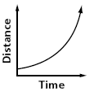
B | 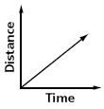
C | 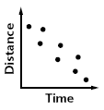
D | 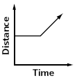

- Kaya made the following graph. Which situation would this graph correctly model?

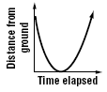

A | an athlete doing the long jump
B | someone playing jump rope
C | someone bouncing a basketball once
D | someone doing one cartwheel

- Which graph best represents the relationship between the weight of a lawnmower bag and the amount of time that passes as the lawn is mowed?

A | 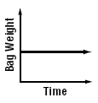
B | 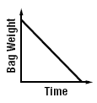
C | 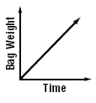
D | 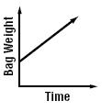

- In Tennessee, property tax rates vary by county. To find the tax rate, divide the tax bill by the assessed value of the property.

The assessed value and tax bills of four properties are shown below. Which county has the lowest property tax rate?

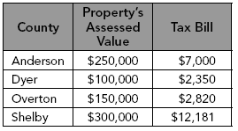

A | Anderson
B | Dyer
C | Overton
D | Shelby

- Tariq purchased 12 roses for $30. Which price represents the cost of roses at the same rate?

A | 24 roses for $50
B | 18 roses for $45
C | 6 roses for $12
D | 1 rose for $2

- Which of the following represents the best buy for cereal?

A | 12 ounces for $2.49
B | 16 ounces for $2.99
C | 21 ounces for $4.49
D | 24 ounces for $4.79

