TCAP Blitz Assessment – 8th Grade
Weeks 1 – 2

- What is the solution to the following system of equations?

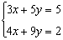

A | (5, –2)
B | 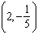
C | (–2, 5)
D | 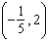

- What is the solution for the system of equations shown below?

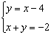

A | (–4, –2)
B | (3, –1)
C | (1, –3)
D | (–1, –3)

- What is the solution for the system of equations shown below?

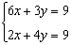

A | 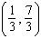
B | (0, 3)
C | 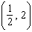
D | (2, –1)

- Given: 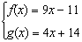

What is the solution to ?

A | –5
B
C
D | 5

- Given: 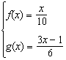

What is the solution to ?

A
B
C
D | 24

- Given: 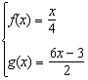

What is the value of x if ?

A | –2
B
C
D | 2

- Which graph shows a line that contains the points in the table of ordered pairs?

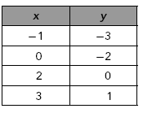

A | 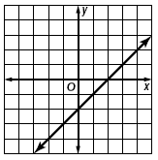
B | 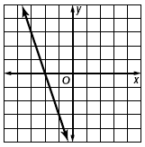
C | 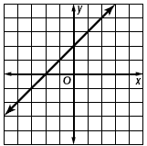
D | 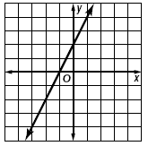

- Which equation best describes the relationship between the corresponding values of x and y in the table?

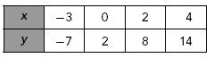

A | y = 3x + 2
B | y = 2x – 1
C | y = x – 4
D | y = –10 – x

- Which equation best describes the relationship between corresponding values of x and y shown in the table?

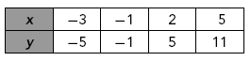

A | y = x – 2
B | y = 2x + 1
C | y = 3x + 4
D | y = 8 + x

- Which graph best represents the equation: 3x = 15 – 5y?

A | 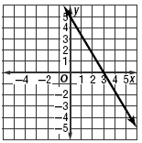
B | 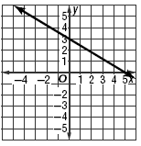
C | 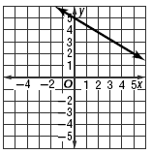
D | 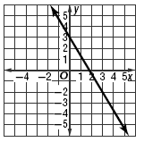

- What is the slope of the line graphed below?

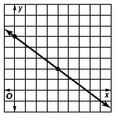

A
B
C
D

- What is the slope of the line given by the equation: y = 3x + 7?

A | 7
B
C | 3
D

- What is the slope of the linear function shown in the graph below?

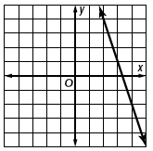

A | –3
B
C
D | 3

- What is the slope of the line given by 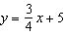?

A
B
C
D | 5

- Which of the following sets of ordered pairs are represented by the line on the graph below?

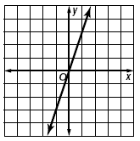

A | 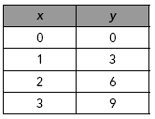
B | 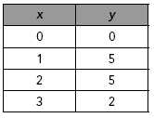
C | 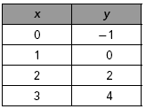
D | 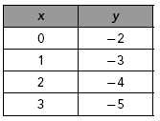

- Which pair of x- and y-intercepts was used to graph the line below?

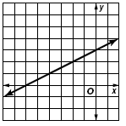

A | x-intercept: 3, y-intercept: –6
B | x-intercept: –3, y-intercept: –6
C | x-intercept: 6, y-intercept: 3
D | x-intercept: –6, y-intercept: 3

- What point names the y-intercept of the line in the graph below?

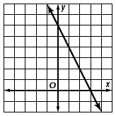

A | (3, 0)
B | (0, 3)
C | (6, 0)
D | (0, 6)

- Which graph shows a nonlinear relationship between time and water level?

A | 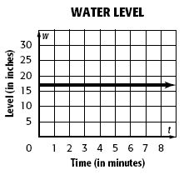
B | 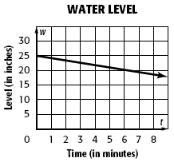
C | 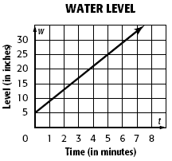
D | 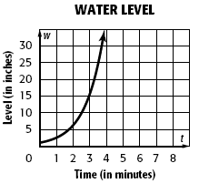

- Which of the following functions is linear?

A | 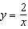
B
C
D

- Which of the following functions is linear?

A
B | 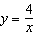
C
D

